DATABASE MANAGEMENT LAB
LAB Report
Submitted in partial fulfilment of the requirement of the degree of
BACHELORS OF TECHNOLOGY
to
K.R Mangalam University



Submitted by: Submitted to
Vansh Tanwar Ms. Mansi Kajal
(2401010102)

Department of Computer Science and Engineering School of Engineering and Technology
K.R Mangalam University, Gurugram- 122001, India SESSION – 2025-2026

Experiment : 1
Question 1. Consider following databases and draw ER diagram and convert entities and relationships to relation table for a given scenario:

COLLEGE DATABASE
STUDENT (USN, SName, Address, Phone, Gender) SEMSEC (SSID, Sem, Sec)
CLASS (USN, SSID)
SUBJECT (Subcode, Title, Sem, Credits)
IAMARKS (USN, Subcode, SSID, Test1, Test2, Test3, FinalIA)
Solution:
- The entities STUDENT, SEMSEC, SUBJECT, and IAMARKS are identified and represented using rectangles.
- The attributes are represented using ellipses:
- STUDENT: USN (Primary Key), SName, Address, Phone, Gender
- USN is underlined as it is the Primary Key.
- Phone is shown as a single-valued attribute.
- SEMSEC: SSID (Primary Key), Sem, Sec
- SSID is underlined as the Primary Key.
- SUBJECT: Subcode (Primary Key), Title, Sem, Credits
- Subcode is underlined as the Primary Key.
- IAMARKS: USN, Subcode, SSID, Test1, Test2, Test3, FinalIA
- USN, Subcode, and SSID together form a composite key.
- Test1, Test2, Test3, and FinalIA are normal attributes.
- Primary keys are represented by underlining the attribute names.
- CLASS is drawn as a relationship (diamond shape) between STUDENT and SEMSEC.
- The relationship between STUDENT and SEMSEC through CLASS is M : 1, meaning many students belong to one semester and section.
- The M : N relationship between STUDENT and SUBJECT is resolved using the associative entity IAMARKS.
- The relationship STUDENT – IAMARKS is 1 : M, indicating one student can have multiple internal assessment records.
- The relationship SUBJECT – IAMARKS is 1 : M, indicating one subject can have multiple IA records for different students.

- The relationship SEMSEC – IAMARKS is 1 : M, showing that marks are maintained semester- section wise.
- All entities, attributes, relationships, primary keys, foreign keys, and cardinalities are clearly represented in the ER diagram.
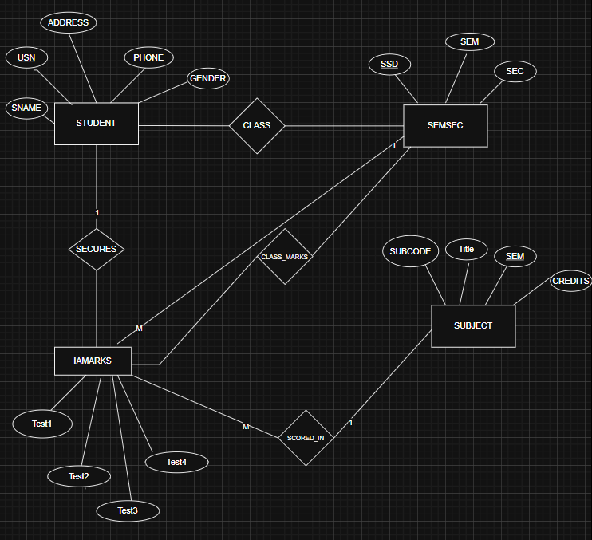
ER DIAGRAM:

Experiment : 2
Question 2. Consider following databases and draw ER diagram and convert entities and relationships to relation table for a given scenario:

COMPANY DATABASE
EMPLOYEE (SSN, Name, Address, Salary, Sex, SuperSSN, DNO) DEPARTMENT (DNo, DName, MgrSSN, MgrStartDate) PROJECT (PNo, PName, PLocation, DNO)
DLOCATION (DNo, DLoc) WORKS_ON (SSN, PNo, Hours) MANAGES (SSN, DNo)
Solution:
- The entities EMPLOYEE, DEPARTMENT, PROJECT, and DLOCATION are identified and represented using rectangles.
- The attributes are represented using ellipses:
- EMPLOYEE: SSN (Primary Key), Name, Address, Salary, Sex, SuperSSN, DNO
- SSN is underlined as it is the Primary Key.
- SuperSSN is a foreign key referencing EMPLOYEE (self-relationship).
- DNO is a foreign key referencing DEPARTMENT.
- DEPARTMENT: DNo (Primary Key), DName, MgrSSN, MgrStartDate
- DNo is underlined as the Primary Key.
- MgrSSN is a foreign key referencing EMPLOYEE.
- PROJECT: PNo (Primary Key), PName, PLocation, DNO
- PNo is underlined as the Primary Key.
- DNO is a foreign key referencing DEPARTMENT.
- DLOCATION: DNo, DLoc
- DNo and DLoc together form a composite key.
- DNo is a foreign key referencing DEPARTMENT.
- WORKS_ON: SSN, PNo, Hours
- SSN and PNo together form a composite key.
- Hours is a descriptive attribute of the relationship.
- Primary keys are represented by underlining the attribute names.
- The relationship WORKS_ON is drawn as a diamond between EMPLOYEE and PROJECT with
M : N cardinality, indicating that:
  - One employee can work on many projects.
  - One project can have many employees.

  - Hours attribute represents the number of hours worked.
- The relationship MANAGES is drawn between EMPLOYEE and DEPARTMENT with 1 : 1 cardinality, indicating:
  - One employee manages one department.
  - Each department has one manager.
- The relationship between EMPLOYEE and DEPARTMENT (via DNO) is M : 1, meaning:
  - Many employees work in one department.
- The relationship between DEPARTMENT and PROJECT is 1 : M, meaning:
  - One department controls many projects.
  - Each project belongs to one department.
- The relationship between DEPARTMENT and DLOCATION is 1 : M, meaning:
  - One department can have multiple locations.
- A recursive relationship exists in EMPLOYEE through SuperSSN, representing that:
  - One employee can supervise many employees.
- All entities, attributes, relationships, primary keys, foreign keys, and cardinalities are clearly represented in the ER diagram.
ER DIAGRAM:
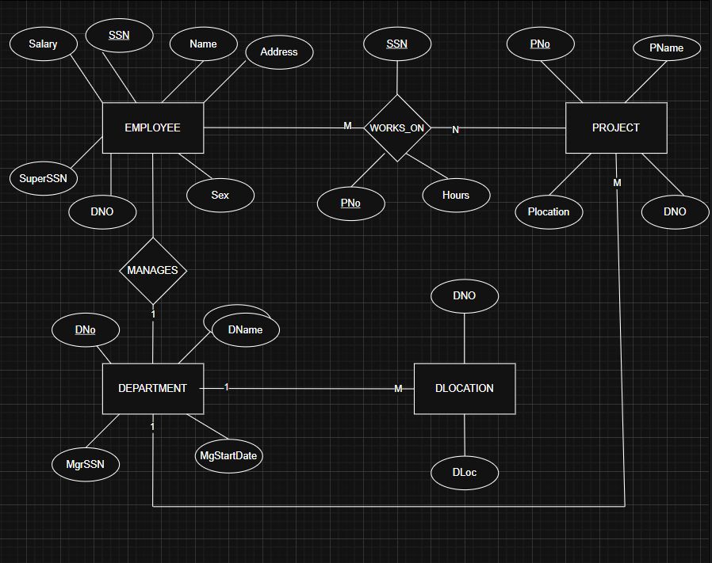

Experiment : 3
Question : Database Schema for a customer-sale scenario Customer(Cust id : integer, cust_name: string) Item(item_id: integer, item_name: string, price: integer)
Sale(bill_no:integer,bill_data:date,cust_id: integer, item_id: integer, qty_sold: integer) For the above schema, perform the following—
- Create the tables with the appropriate integrity constraints.
Output:
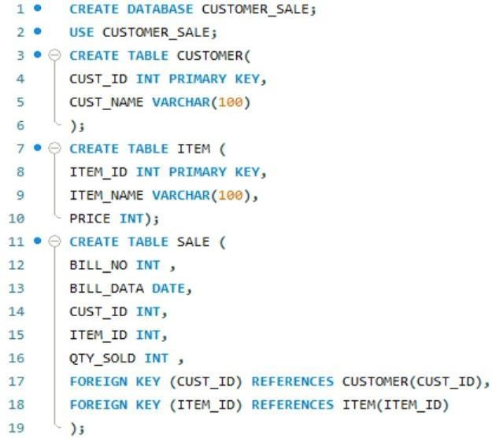

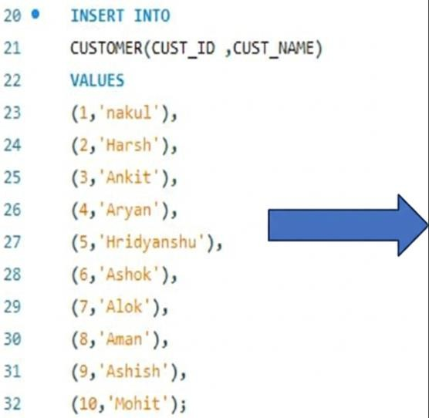
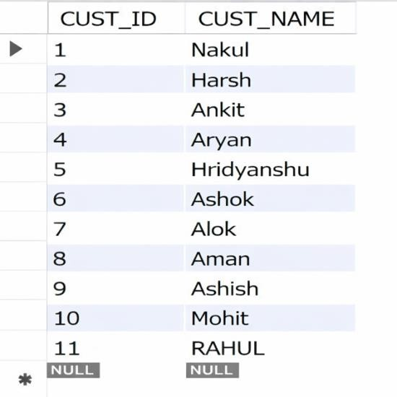
- Insert around 10 records in each of the tables.

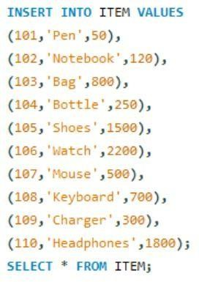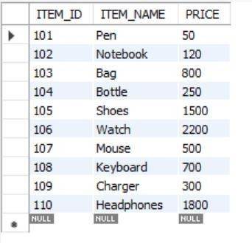
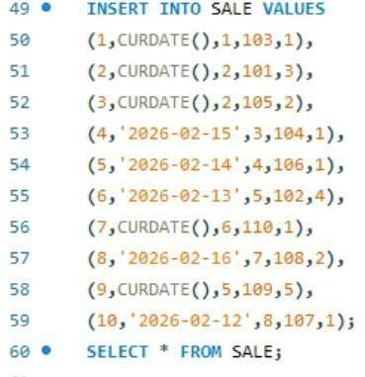
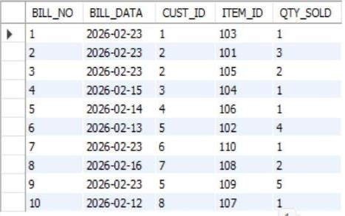
- List all the bills for the current date with the customer names and item numbers

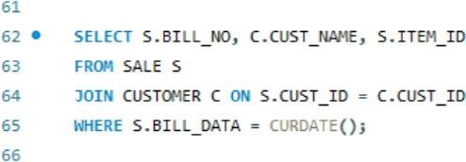
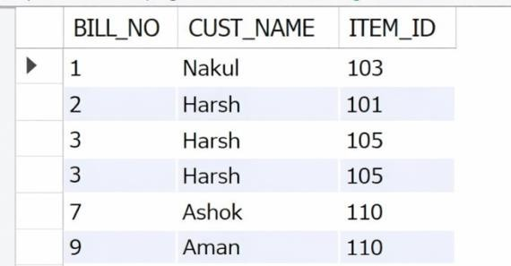

- List the total Bill details with the quantity sold, price of the item and the final amount.

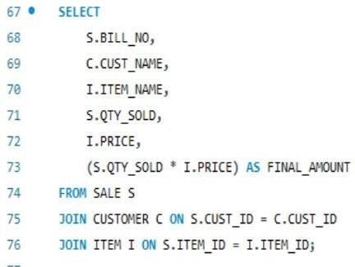
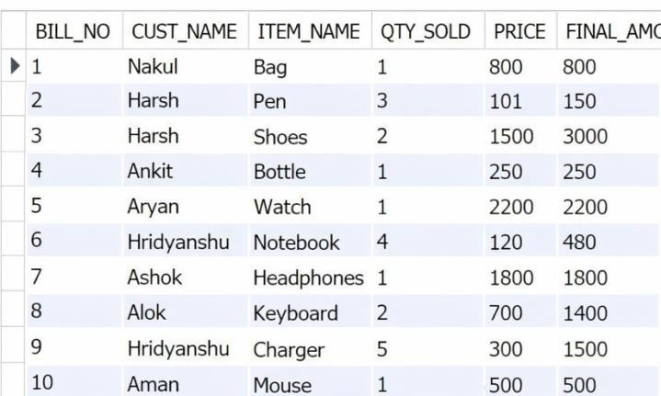
- List the details of the customer who have bought a product which has a price>200
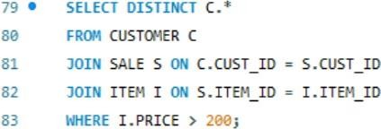
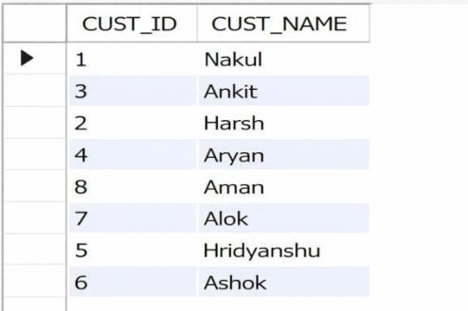
- Give a count of how many products have been bought by each customer
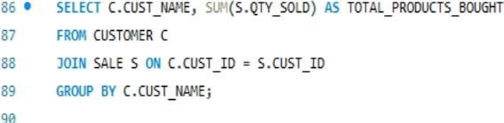
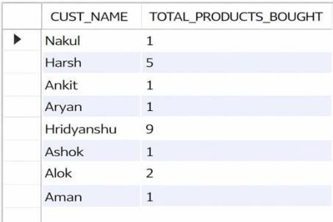
- Give a list of products bought by a customer having cust_id as 5.
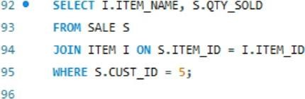
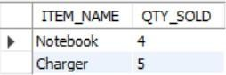
z

- List the item details which are sold as of today.
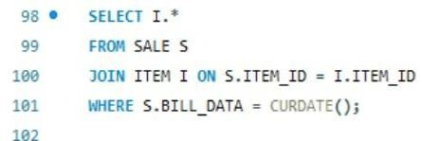
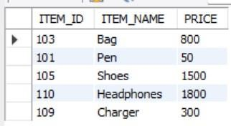
- Create a view which lists out the bill_no, bill_date, cust_id, item_id, price, qty_sold,Amount
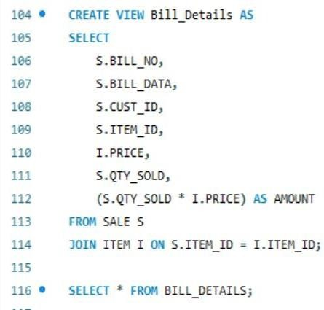
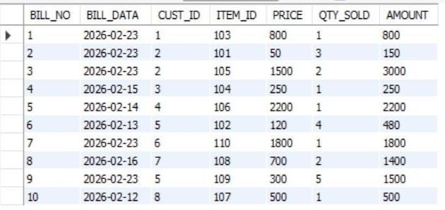
- Create a view which lists the daily sales date wise for the last one week
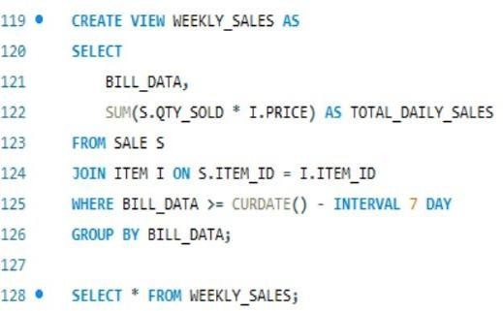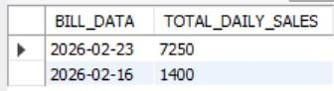

Experiment: 4
Question: Consider the following table: Table: CLASS (ID,Name)
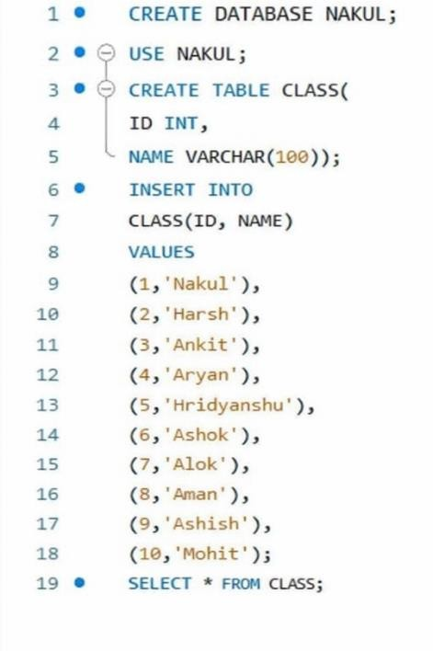
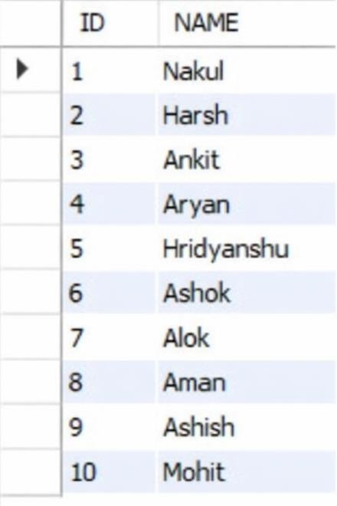

- SET AUTOCOMMIT = 0; and START TRANSACTION;
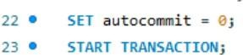

- INSERT INTO class VALUES (11,’Rahul’);
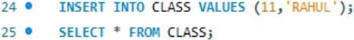
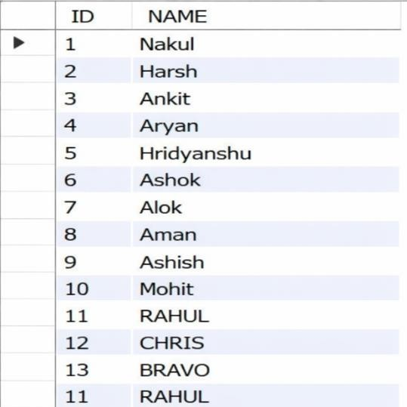

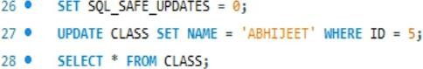
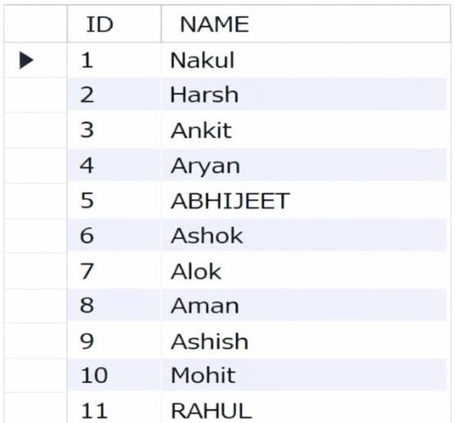
- UPDATE class SET name = ‘Abhijeet’ WHERE id= ‘5’;

- SAVEPOINT A:
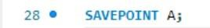
- INSERT INTO class VALUES (12, ‘Chris’);
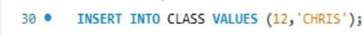
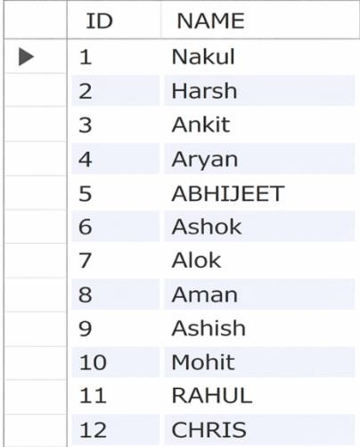
- SAVEPOINT B;

- INSERT INTO class VALUES (13, ‘Bravo’);
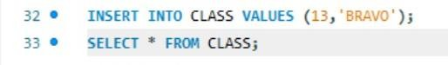
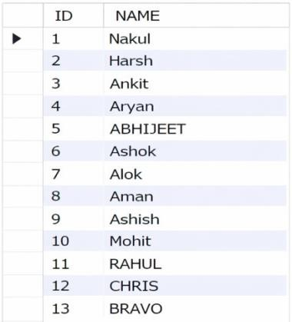

- SAVEPOINT C;
- ROLLBACK TO B;
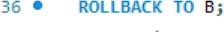
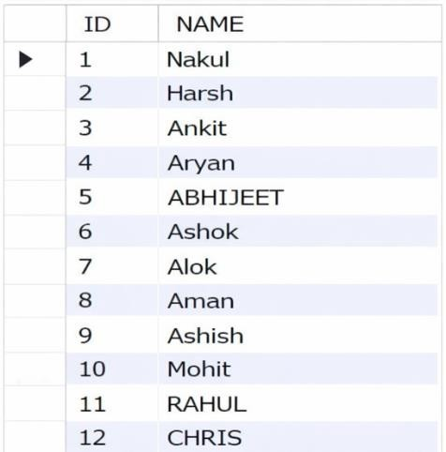
- ROLLBACK TO A;
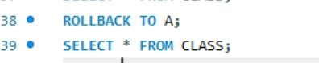
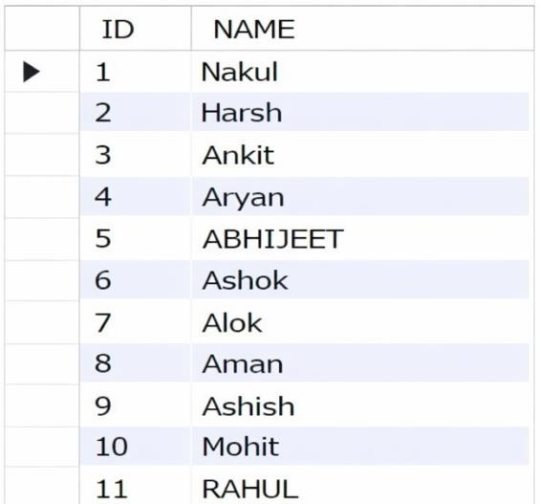

- COMMIT;

Experiment: 4.2
Consider the following table: Table: ACCOUNT_TXN Acc_ID Holder_Name Balance
101 | Aman | 5000
102 | Bhavna | 7000
103 | Chirag | 6000
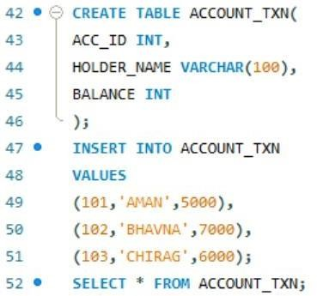
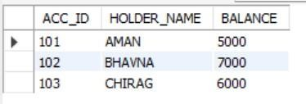
Perform the following TCL-based SQL script and write the output after each SELECT statement:
- INSERT INTO ACCOUNT_TXN VALUES (104, 'Diya', 4000);
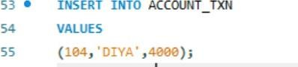
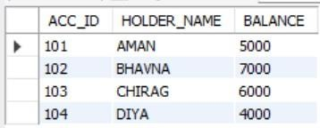

SAVEPOINT S1
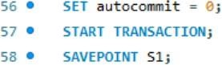
- UPDATE ACCOUNT_TXN SET Balance = Balance + 1500 WHERE Acc_ID = 101
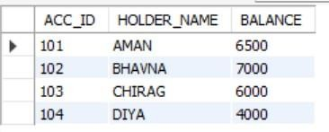

- UPDATE ACCOUNT_TXN SET Balance = Balance - 1000 WHERE Acc_ID = 102
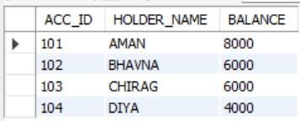

SAVEPOINT S2;

- DELETE FROM ACCOUNT_TXN WHERE Acc_ID = 103
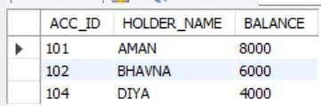

- INSERT INTO ACCOUNT_TXN VALUES (105, 'Eshan', 3000);
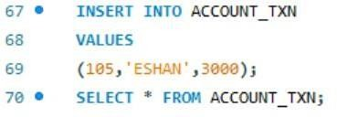
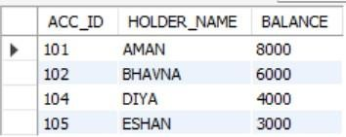

SAVEPOINT S3
- UPDATE ACCOUNT_TXN SET Holder_Name = 'Bhavna Sharma' WHERE Acc_ID = 102;
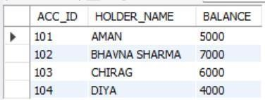

ROLLBACK TO S2;
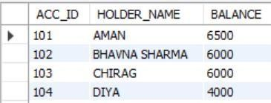
- INSERT INTO ACCOUNT_TXN VALUES (106, 'Farah', 4500)
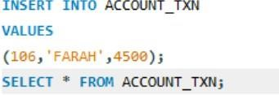
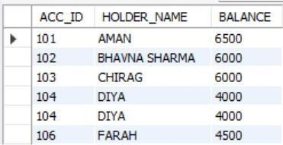

SAVEPOINT S4;
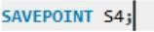
- UPDATE ACCOUNT_TXN SET Balance = Balance + 500 WHERE Acc_ID IN (101,104); SELECT * FROM ACCOUNT_TXN
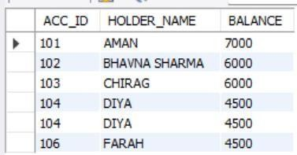
- ROLLBACK TO S4;
SELECT * FROM ACCOUNT_TXN;
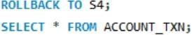
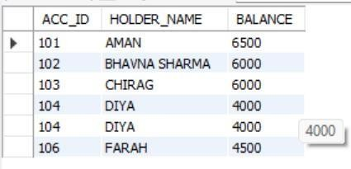

- COMMIT
- Identify which rows are permanently saved after COMMIT.
